Western Region Jeddah

Pcs For Western Region Jeddah:

1-

IP: 192.170.2.3

F0/3

F0

default gateway :192.170.2.7

2-

IP: 192.170.2.2

F0/2

F0

default gateway :192.170.2.7

Laptop For Western Region Jeddah:

IP: 192.170.2.1

F0/4

F0

default gateway :192.170.2.7

Printer For Western Region Jeddah:

IP:192.170.2.4

Server For Western Region Jeddah:

IP:192.170.2.10

Gateway For Western Region Jeddah:

HomeGateway01

192.168.25.1

Router (1841) For Western Region Jeddah:

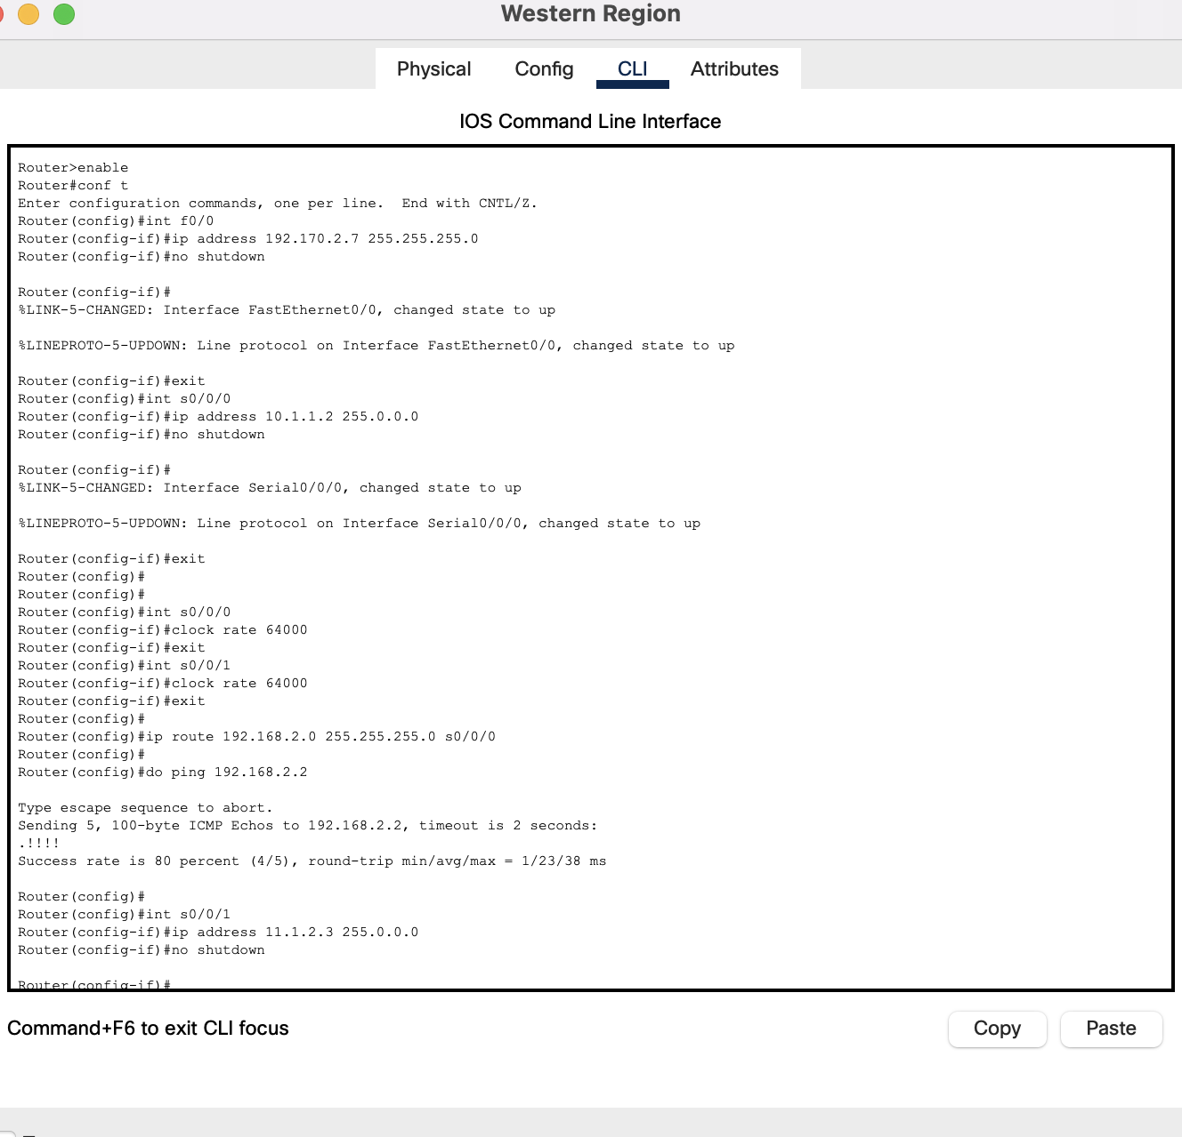

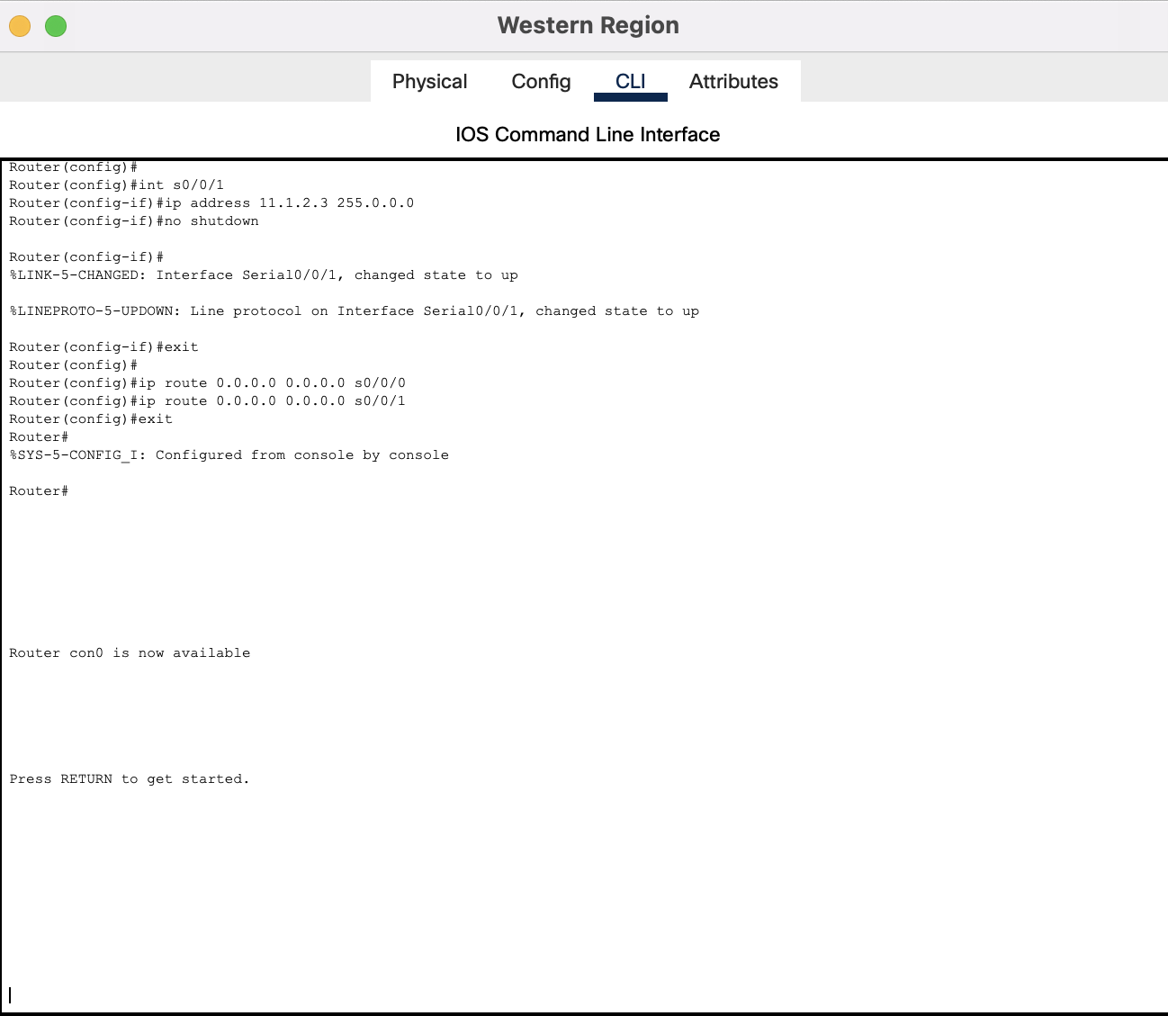

Router (2811) For Western Region Jeddah:

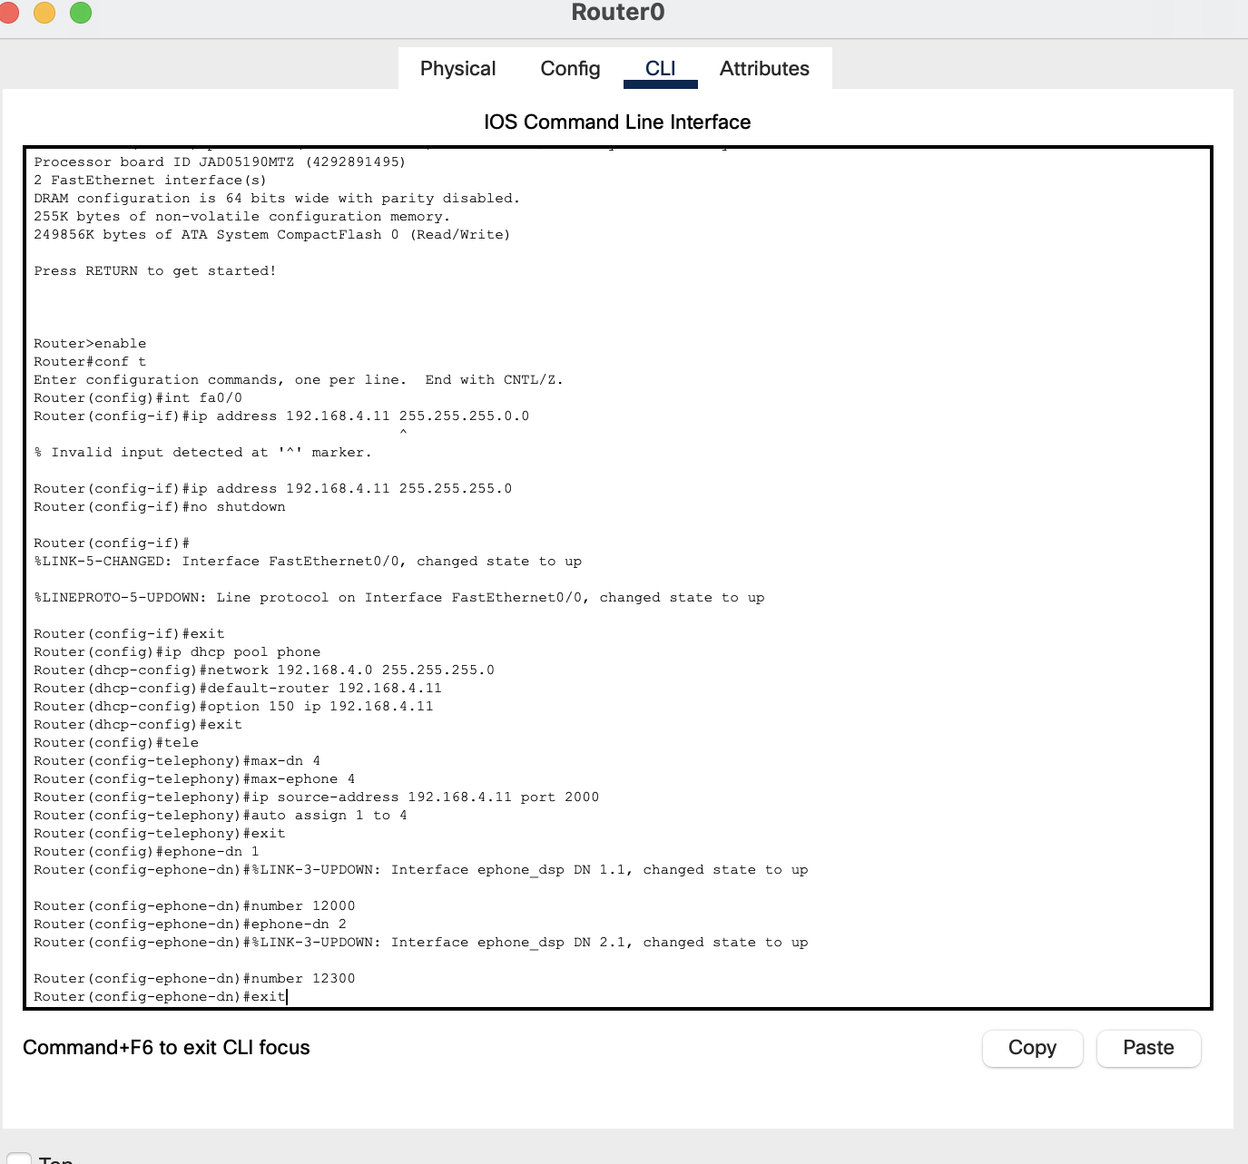

Switch (2960) For Western Region Jeddah:

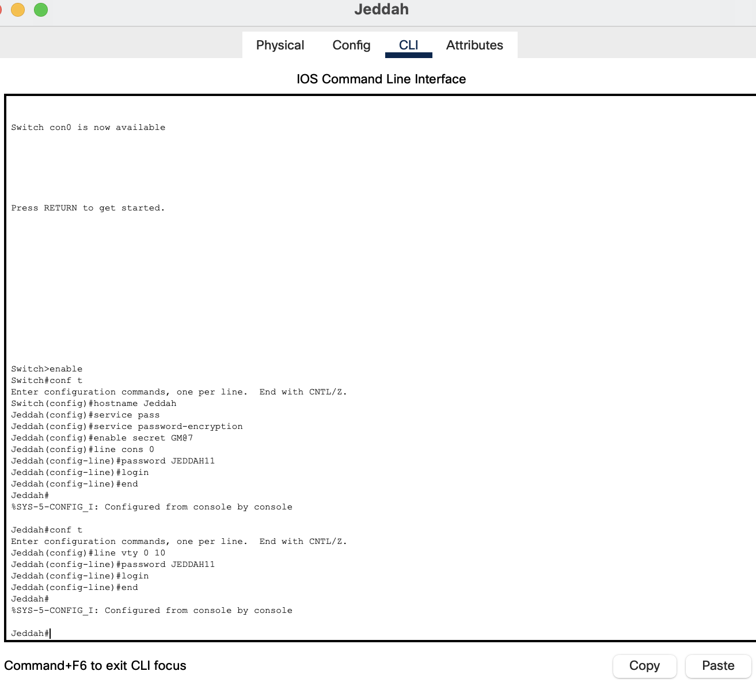

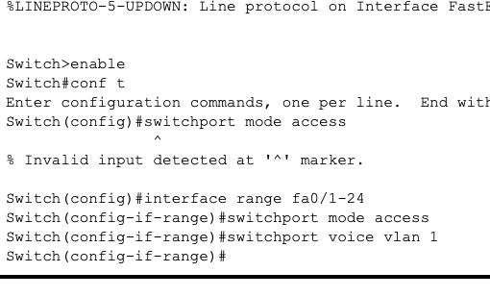

Server For Western Region Jeddah:

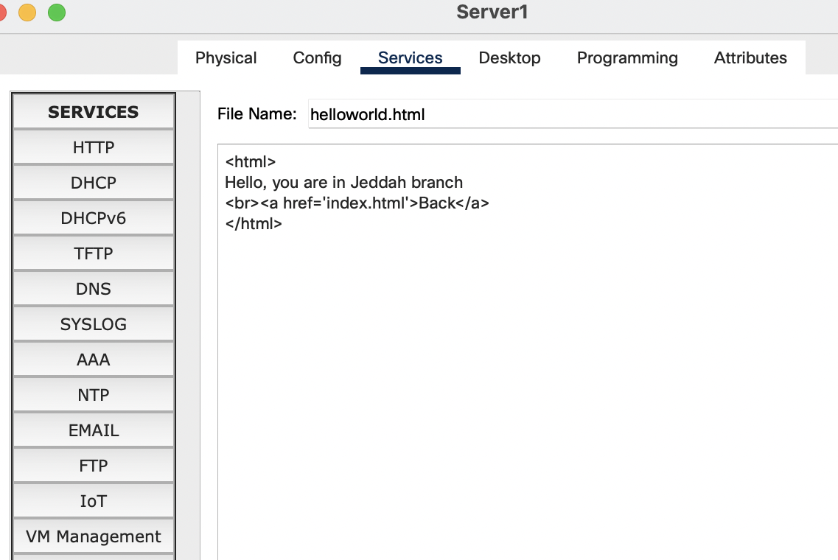

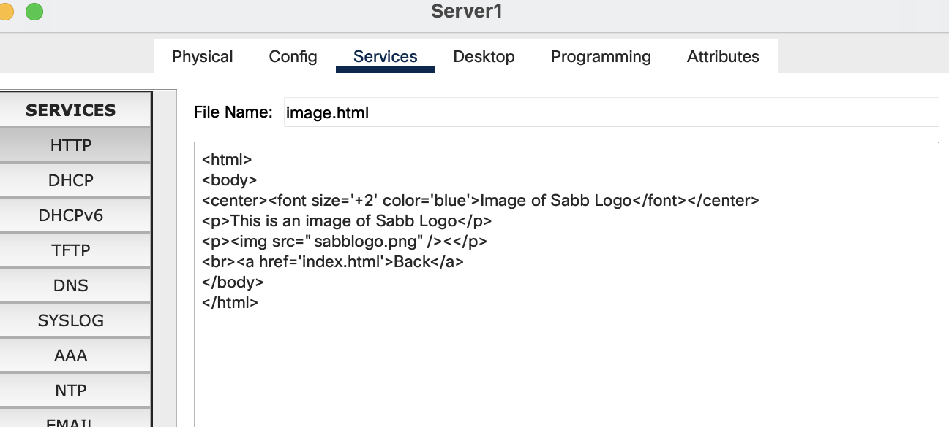

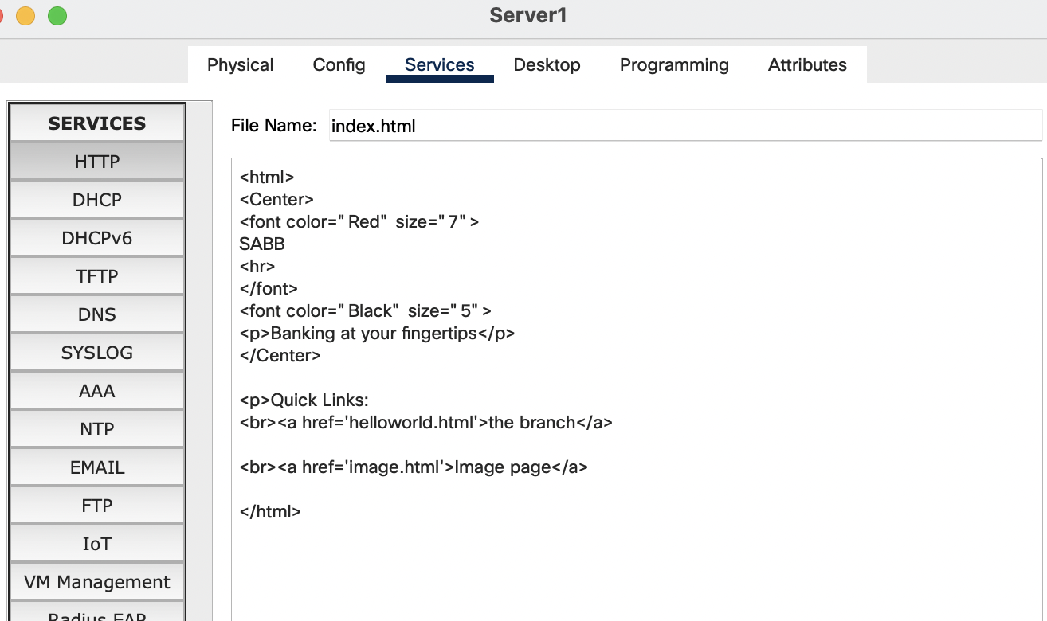

Fire Detectot (Python)

